Firefighter Bot Proposal
TEJ4MI
Mr. Ellis
Lucas Li

Description

Challenge Statement
Although my firefighter bot may not particularly stand out in physical design and structure, my bot will have a unique software and actual configuration in the maze. My bot will feature a triple layer design with the dimensions 15 cm x 15 cm x 21 cm .I will rely on my creativity and critical problem solving to design a unique bot in terms of actual performance. By analyzing past success and entering this project with a determined mindset, I intend to complete as much as both mazes as possible, as fast as possible. I will be able to test multiple strategies and experiment with different code to figure out which approaches work the most efficiently and effectively.

Line Detection
My bot will use a line detection board to navigate through the maze and recognize different rooms. A superbright LED will be shined onto the floor with a Vishay BPW17N phototransistor to detect the reflected light. Whenever the bot is on a black surface, there will be little to no reflected light, which keeps the voltage above 1.8 volts, resulting in a digital signal of 1. On the other hand, when the bot crosses a white line, the light from the superbright LED will reflect light, which will drop the voltage below 0.8 volts, outputting a digital signal of 0. Whenever the voltage from the pin that is connected to the output of the line detection drops to 0, the bot will detect that a line has been crossed. Using these inputs from the line detection, my bot can keep track of the lines and understand which room it is currently in, aiding my maze navigation.

Wall Detection
My bot will feature two Parallax 28015 distance sensors, with one mounted to the left of the chassis and the other one mounted to the front. With these two sensors, I will be able to apply a wall-hugging algorithm that will serve as the foundation for more complex strategies. my bot will focus on maintaining a distance of 12 centimeters from the wall to the left. If the distance from the left sensor input is greater than 12 centimeters, the bot will temporarily pause the left motor so that the right motor can force the bot to veer slightly leftward, reducing the distance until it reaches 12 centimeters again. Conversely, if the left sensor input reads a distance of less than 12 centimeters, the bot will pause the right motor, causing the bot to veer rightward instead, increasing the distance until it reaches 12 centimeters again. Whenever the distance is right around 12 centimeters, the bot will proceed forward as usual. Since I am relying on the distance from the left wall, left turns will happen by default, but I still need to apply additional programming to take right turns into consideration. When the front sensor does not detect any walls, the bot can continue to hug the left wall. However when both the left and front sensors are detecting a wall, that means the only possible path is rightward. In this case, there will be a right turn function, turning the left motor on and reversing the polarity on the right motor to make it go backward. This will make the bot spin clockwise, and I will perform tests to determine the exact length of time the bot will spend spinning for consistent turns. This wall-hugging algorithm covers all the cases required for basic maze navigation, providing a solid foundation for me to build upon.

Flame Detection and Board
To handle fire detection and distinguishing, my bot will utilize a QSD123 infrared phototransistor along with a 103k Ω resistor to detect the specific light signatures of a candle flame. Once a flame is detected, the bot will trigger the fire distinguisher board to distinguish the flame. This board is designed to be consistent and reliable, utilizing a TIP120 semiconductor as a switch to activate the distinguishing mechanism. To protect the sensitive logic components from logic spikes caused by the motor or pump, a 1N4001G diode is incorporated into the board for flyback protection, while a 1000 µF capacitor is used to stabilize the power supply to prevent resets during high-draw moments. A 10k Ω resistor is also integrated into the circuit to ensure the transistor switches cleanly and efficiently. By combining this precise detection hardware with a heavy-duty power delivery circuit with filtering, the bot can seamlessly transition from its wall-hugging navigation to an active fire distinguishing mode when a heat source is detected.

Motherboard and Motor Driver
The brains of my bot will reside on a custom motherboard centered around the ATMEGA328P-PU microchip, which processes sensor data and executes navigation logic. To output real-time feedback and debugging information, I will integrate an NHD-0216K1Z-NSW-FBW-L LCD display, with a 100k Ω potentiometer to allow for precise contrast adjustment for readability. Additionally, a 233k Ω resistor will be utilized within the board to ensure stable signal references for the processor. For actual movement, the bot will carry a pair of high-torque Nema 17 stepper motors secured with strong motor brackets designed specifically for the Nema 17 motors. These motors will be driven by TI SN754410NE motor driver chip; a quadruple high-current, half-H driver, capable of bidirectional control. In order to handle the significant current spikes that are to be expected from the stepper motors, a powerful 10,000 µF capacitor is placed on the power fail to smooth out voltage ripples, while 33k Ω resistors are used to pull the logic pins to their appropriate states, ensuring the motors respond reliably to the microchip’s commands.

Materials List

Component | Price
General  - Wheels  - Screws  - Bolts  - Wood Panels  - Nuts  - Ribbon Cables | General  - $5.03 RobotShop  - $4.91 from Amazon  - 4 x $6.19 from Home Depot  - Provided  - 2 x $8.19 from Amazon  - 2 x $4.00 Spool3D
Line Detection  - 1k Ω Resistor (R2)  - 85k Ω Resistor (R3)  - Superbright Led (D2)  - Vishay BPW17N Phototransistor (Q3) | Line Detection  - $0.15 from DigiKey  - $0.37 from DigiKey  - $0.48 from DigiKey  - $1.29 from DigiKey
Wall Detection  - 4 µF Capacitor (C5)  - TPSA476K006R0800 47 µF Capacitor (C6)  - Parallax 28015 Distance Sensor | Wall Detection  - $0.43 from DigiKey  - $1.15 from Mouser  - 2 x $34.95 from Parallax
Flame Detection  - 103k Ω Resistor (R4)  - QSD123 Infrared Phototransistor (Q2) | Flame Detection  - $0.87 from DigiKey  - $1.08 from DigiKey
Fire Distinguisher Board  - 1N4001G Diode (D1)  - 1000 µF Capacitor (C1)  - Fairchild Semiconductor TIP120 (Q1)  - 10k Ω Resistor (R5) | Fire Distinguisher Board  - $0.22 from DigiKey  - $2.44 from Mouser  - $1.72 from DigiKey  - $0.14 from DigiKey
Motherboard  - 100k Ω Potentiometer (R1)  - NHD-0216K1Z-NSW-FBW-L LCD Display  - 233k Ω Resistor (R6)  - ATMEGA328P-PU Microchip | Motherboard  - $1.88 from DigiKey  - $15.14 from DigiKey  - $0.24 from DigiKey
Motor Driver  - TI SN754410NE Motor Driver Chip  - 10,000 µF Capacitor (C3)  - 33k Ω Resistor (R7 & R8)  - Nema 17 Stepper Motor  - Motor Bracket | Motor Driver  - $5.74 from DigiKey  - $13.52 from Mouser  - 2 x $0.14 from DigiKey  - 2 x $13.50 from Amazon  - 2 x $5.99 from Tinkersphere
Total Price | $215.10

Timeline

February and March - Breadboarding
23  Working on proposal | 24  Working on proposal | 25  Working on flash LED | 26  Troubleshooting flash LED | 27  Working on motors | 28  Weekend | 01  Weekend
02  Testing directional logic | 03  Working on line detection | 04  Calibrating IR sensor sensitivity | 05  Mapping sensor inputs | 06  Trouble-  shooting false positives | 07  Weekend | 08  Weekend
09  More trouble-  shooting | 10  Working on LCD | 11  Wiring parallel interface pins | 12  Programming and testing | 13  Testing real-time status updates | 14  Weekend | 15  Weekend
16  March break | 17  March break | 18  March break | 19  March break | 20  March break | 21  March break | 22  March break
23  Working on wall detection | 24  Testing avoidance logic | 25  Working on flame detection | 26  Testing IR flame sensor range | 27  Trouble-  shooting false positives | 28  Weekend | 29  Weekend
30  Working on distinguisher (fan) | 31  Integrating and testing fan logic

April - PCB Board
30 | 31 | 01  Working on motors | 02  Soldering screw terminals | 03  Mounting motor driver to chassis | 04  Weekend | 05  Weekend
06  Working on line detection (etching) | 07  Creating custom headers | 08  Ensure sensors sit at a fixed height | 09  Cleaning up cable management | 10  Testing and trouble-  shooting | 11  Weekend | 12  Weekend
13  Finalize testing with actual lines | 14  Working on LCD | 15  Soldering pins | 16  Mounting the LCD | 17  Adjusting contrast with potentiometer | 18  Weekend | 19  Weekend
20  Testing LCD outputs | 21  Working on wall detection | 22  Ensuring sensors are level | 23  Soldering capacitor to the power rail | 24  Finalizing LCD (troubleshoot) | 25  Weekend | 26  Weekend
27  Working on flame detection | 28  Soldering IR sensor | 29  Finalizing sensor’s position | 30  Testing and trouble-  shooting

May - Finalizing Firefighter Bot
27 | 28 | 29 | 30 | 01  Working on distinguishing board | 02  Weekend | 03  Weekend
04  Soldering fan-driver circuit | 05  Optimally securing fan to chassis | 06  Trouble-  shooting and testing bot | 07  Trouble-  shooting and testing bot | 08  Trouble-  shooting and testing bot | 09  Weekend | 10  Weekend
11  Trouble-  shooting and testing bot | 12  Trouble-  shooting and testing bot | 13  Trouble-  shooting and testing bot | 14  Trouble-  shooting and testing bot | 15  Trouble-  shooting and testing bot | 16  Weekend | 17  Weekend
18  Working on bot in maze | 19  Working on bot in maze | 20  Working on bot in maze | 21  Working on bot in maze | 22  Working on bot in maze | 23  Weekend | 24  Weekend
25  Working on bot in maze | 26  Working on bot in maze | 27  Working on bot in maze | 28  Working on bot in maze | 29  Working on bot in maze | 30  Weekend | 31  Weekend

June - Completing the Mazes
01  Working on bot in maze | 02  Working on bot in maze | 03  Working on bot in maze | 04  Working on bot in maze | 05  Working on bot in maze | 06  Weekend | 07  Weekend
08  Working on bot in maze | 09  Working on bot in maze | 10  Working on bot in maze | 11  Working on bot in maze | 12  Working on bot in maze | 13  Weekend | 14  Weekend
15  Working on bot in maze | 16  Working on bot in maze | 17  Working on bot in maze | 18  Working on bot in maze | 19  Working on bot in maze | 20  Weekend | 21  Weekend
22  Working on bot in maze | 23  Working on bot in maze | 24  Working on bot in maze | 25  Working on bot in maze | 26  Summer | 27  Weekend | 28  Weekend
29  Summer | 30  Summer | 31  Summer

Drawings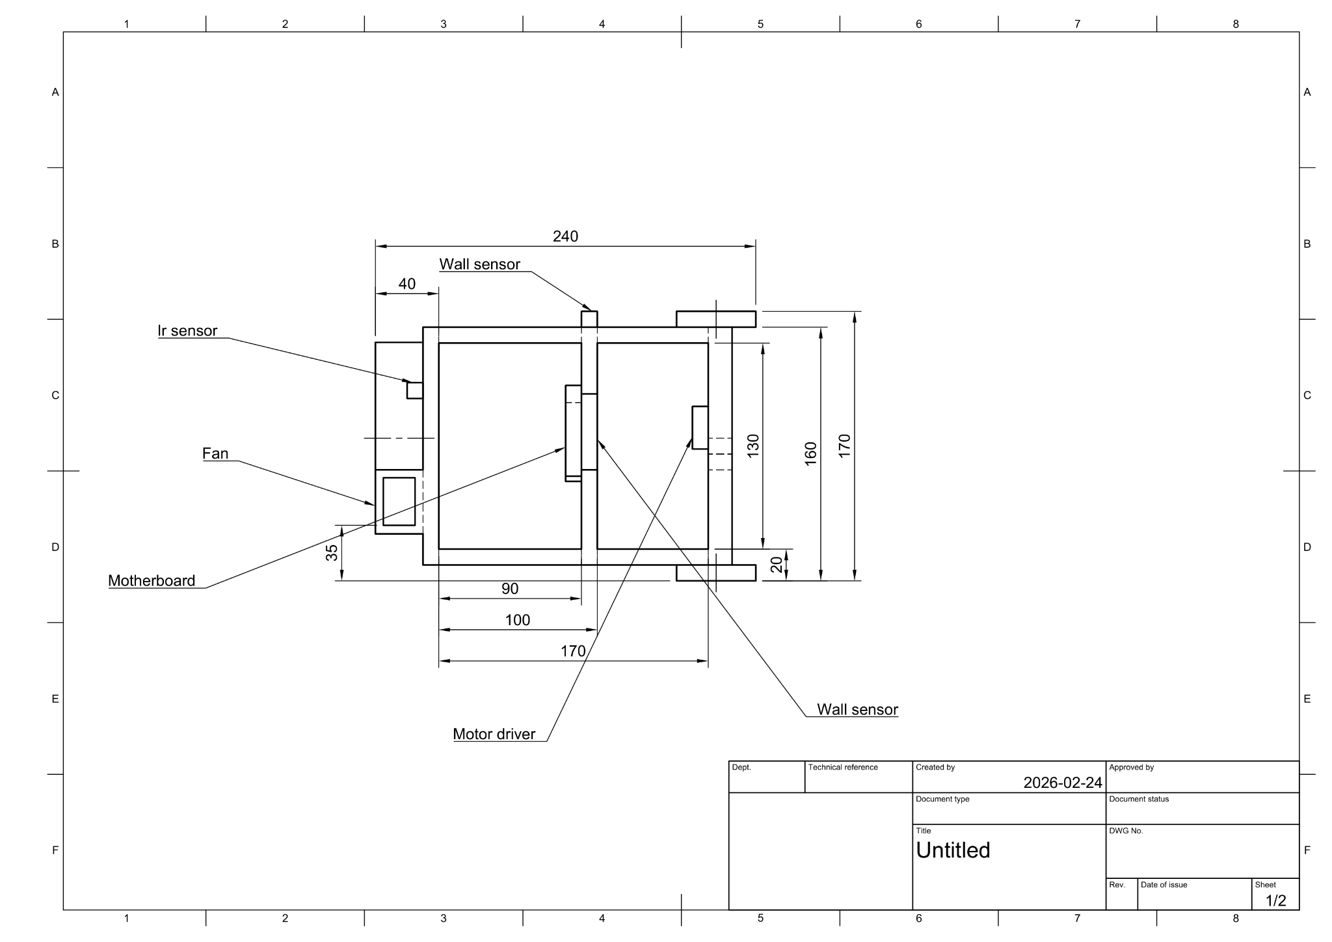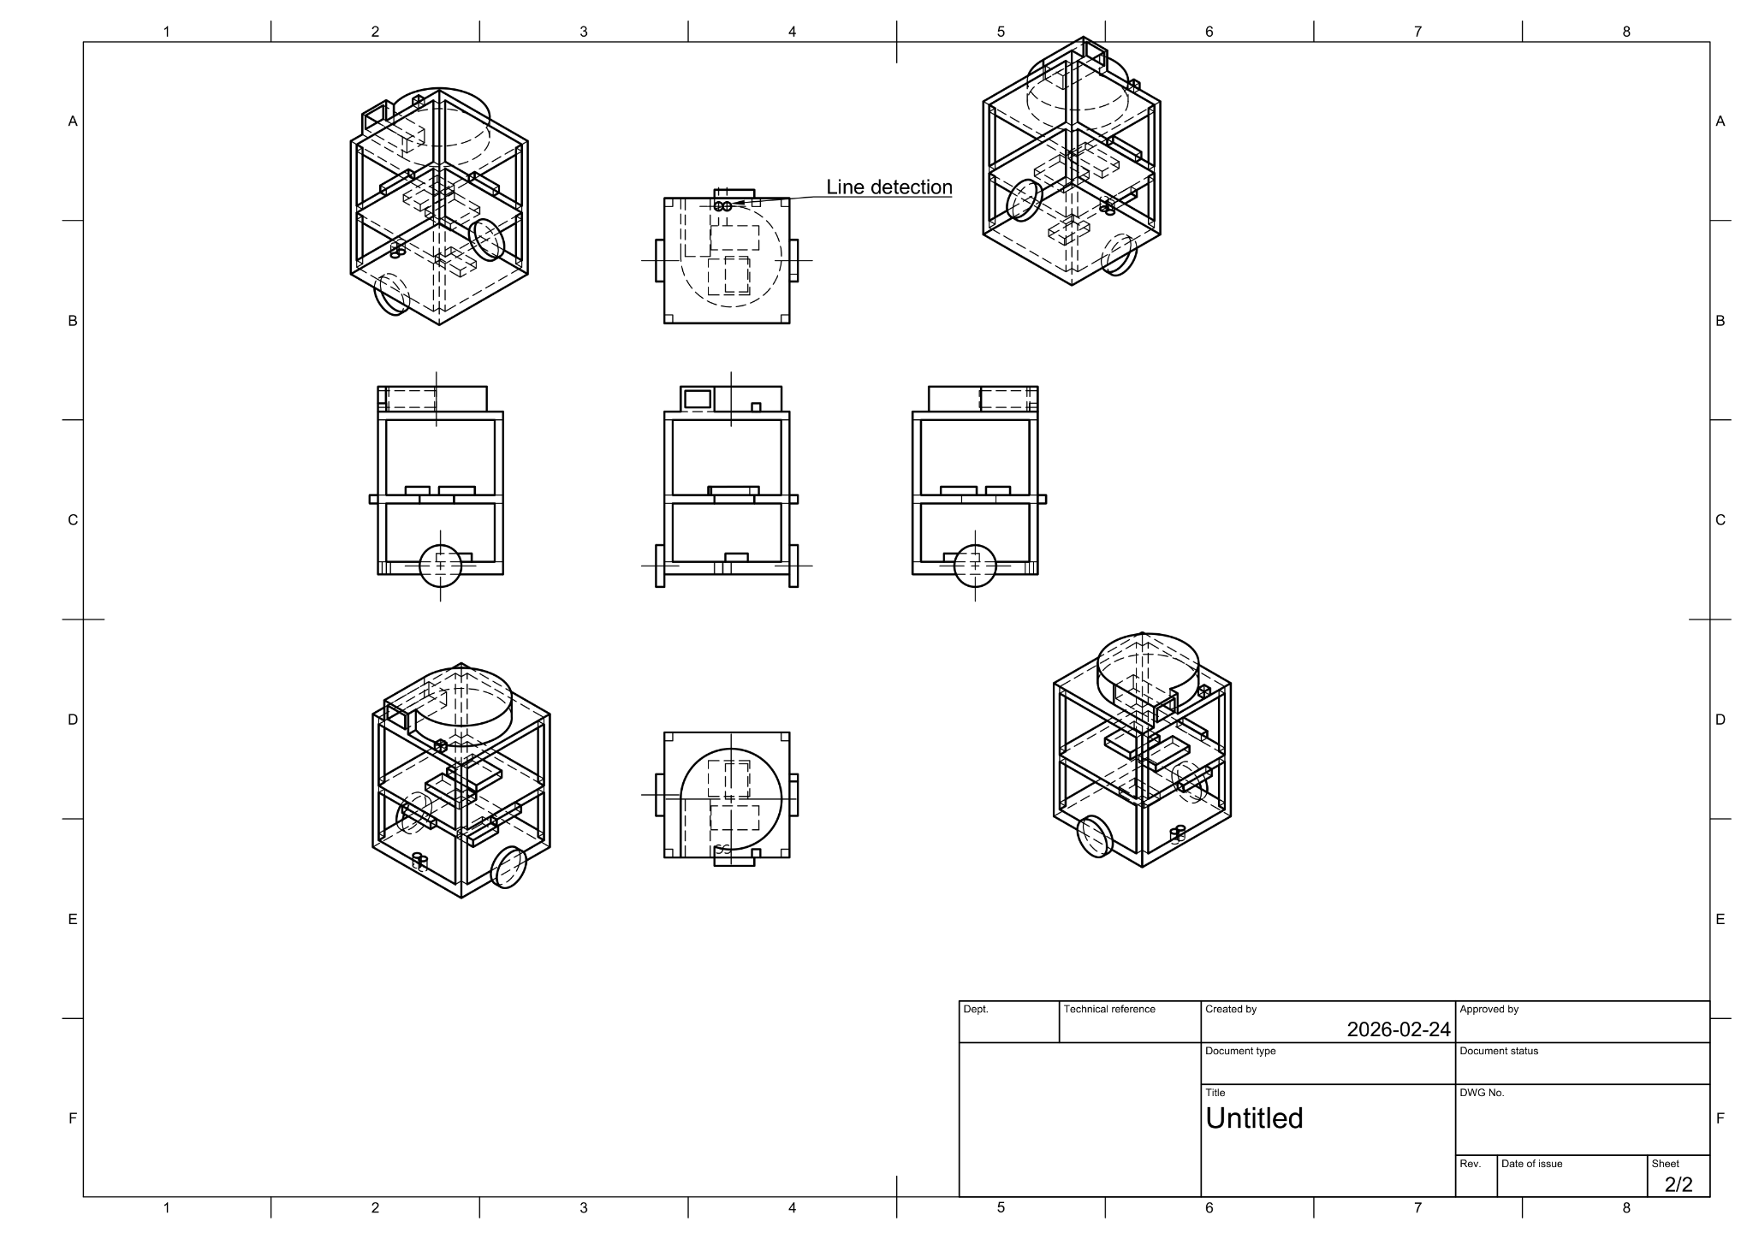
15 cm
21 cm
15 cm

